RENT Class Design

# Create Initial Design Classes

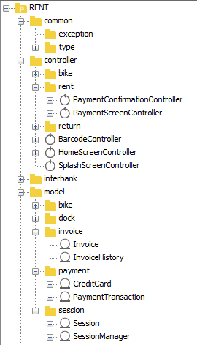 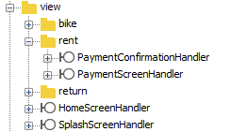

# Define Relationships Between Classes

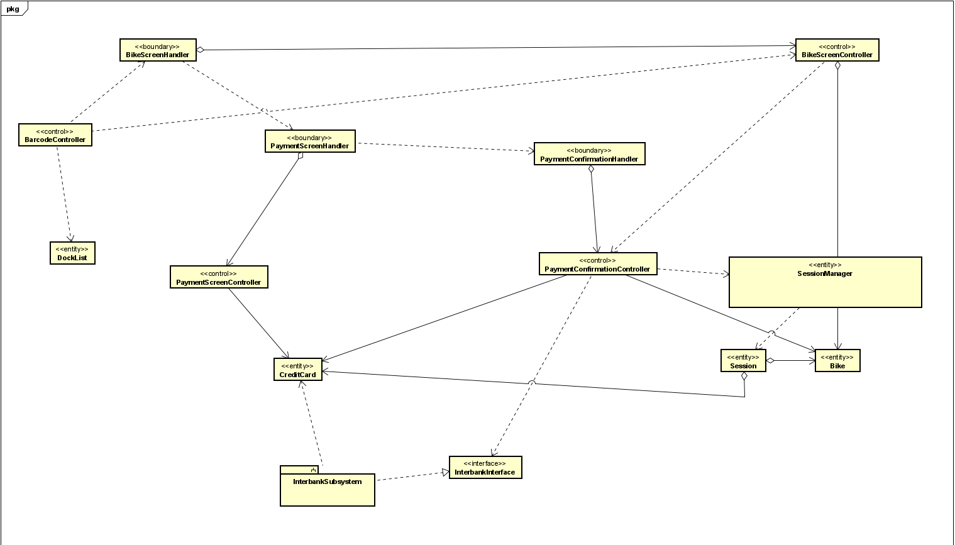

# Class Design

## Class “BarcodeController”

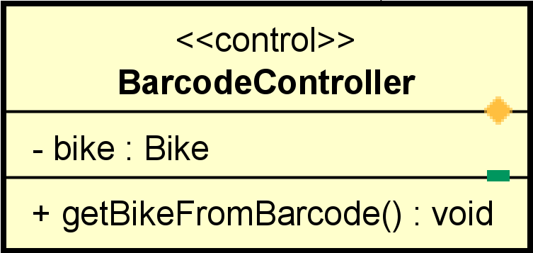

**Attribute**

|  |  |  |  |  |
| --- | --- | --- | --- | --- |
| # | Name | Data type | Default value | Description |
| 1 | bike | Bike | NULL | The result of barcode searching |

**Operation**

|  |  |  |  |
| --- | --- | --- | --- |
| # | Name | Return type | Desciption |
| 1 | getBikeFromBarcode | void | Get bike using barcode from DockList |

Parameter:

None

Exception:

None

**Method**

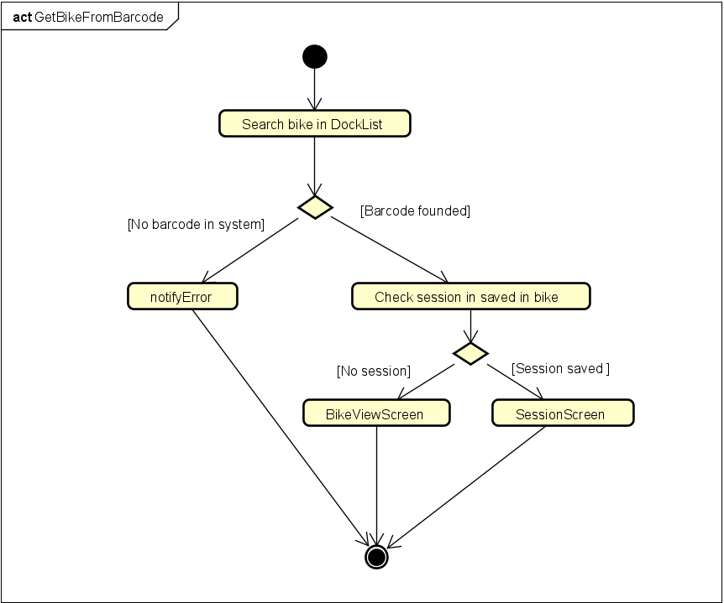

**State**

None

## Class “PaymentScreenHandler”

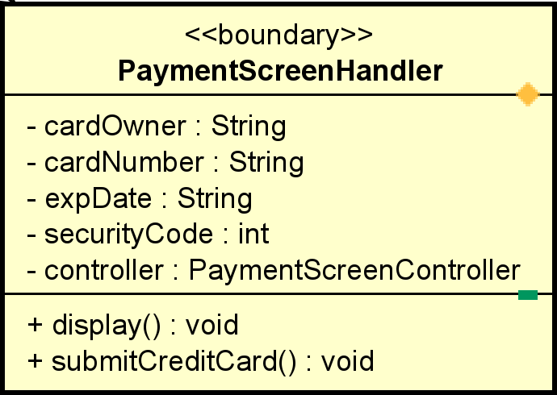

**Attribute**

|  |  |  |  |  |
| --- | --- | --- | --- | --- |
| # | Name | Data type | Default value | Description |
| 1 | controller | PaymentScreenController | NULL | Controller for this screen |
| 2 | cardOwner | String | Empty | Card owner |
| 3 | cardNumber | String | Empty | Card number |
| 4 | expDate | String | Empty | Expired Date |
| 5 | securityCode | Int | Empty | Security Date |

**Operation**

|  |  |  |  |
| --- | --- | --- | --- |
| # | Name | Return type | Desciption |
| 3 | display | void | Display screen |
| 4 | submitCreditCard | void | Send card to next handler |

Parameter:

None

Exception:

None

**Method**

None

**State**

None

## Class “PaymentScreenController”

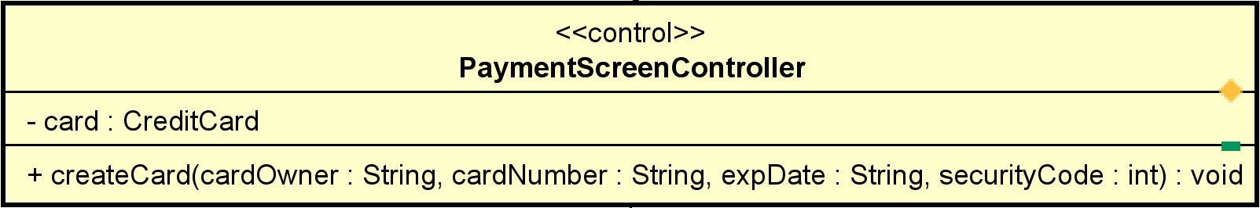

**Attribute**

|  |  |  |  |  |
| --- | --- | --- | --- | --- |
| # | Name | Data type | Default value | Description |
| 1 | card | CreditCard | NULL | Card for payment |

**Operation**

|  |  |  |  |
| --- | --- | --- | --- |
| # | Name | Return type | Desciption |
| 1 | createCard | void | Create an instance of CreditCard |

Parameter:

cardOwner – card owner

cardNumber – card number

expDate – expired date

securityCode – security code

Exception:

None

**Method**

None

**State**

None

## Class “PaymentConfirmationHandler”

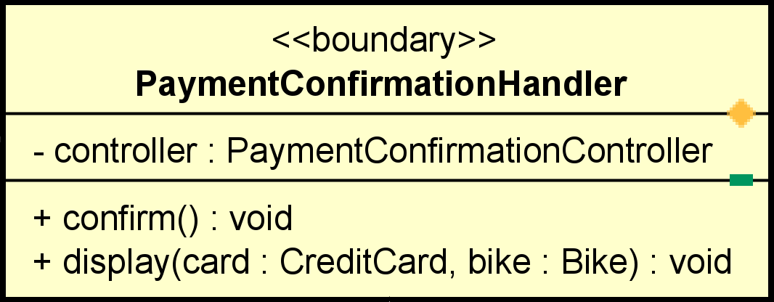

**Attribute**

|  |  |  |  |  |
| --- | --- | --- | --- | --- |
| # | Name | Data type | Default value | Description |
| 1 | controller | PaymentConfirmationController | NULL | Controller for this screen |

**Operation**

|  |  |  |  |
| --- | --- | --- | --- |
| # | Name | Return type | Desciption |
| 1 | display | void | Display screen |
| 2 | confirm | void | Move to next screen |

Parameter:

None

Exception:

None

**Method**

None

**State**

None

## Class “PaymentConfirmationController”

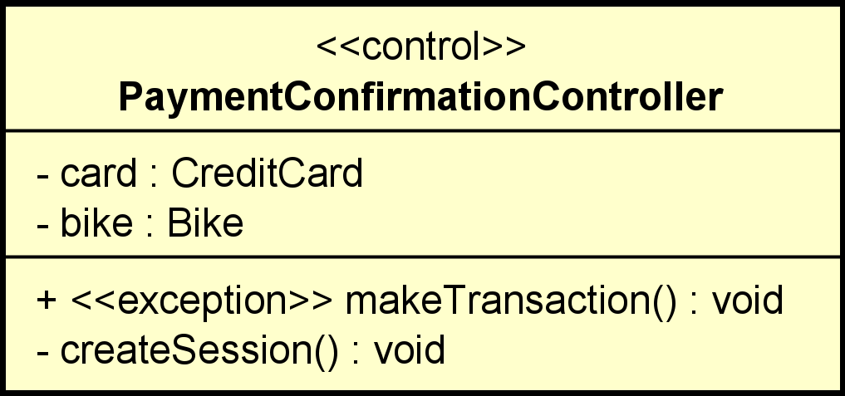

**Attribute**

|  |  |  |  |  |
| --- | --- | --- | --- | --- |
| # | Name | Data type | Default value | Description |
| 1 | card | CreditCard | NULL | Card for payment |
| 2 | bike | Bike | NULL | Bike for renting |

**Operation**

|  |  |  |  |
| --- | --- | --- | --- |
| # | Name | Return type | Desciption |
| 1 | makeTransaction | void | Make transaction |
| 2 | createSession | void | Create new Session |

Parameter:

None

Exception:

InvalidCardException

NotEnoughBalanceException

InternalServerErrorException

**Method**

None

## Class “SessionManager”

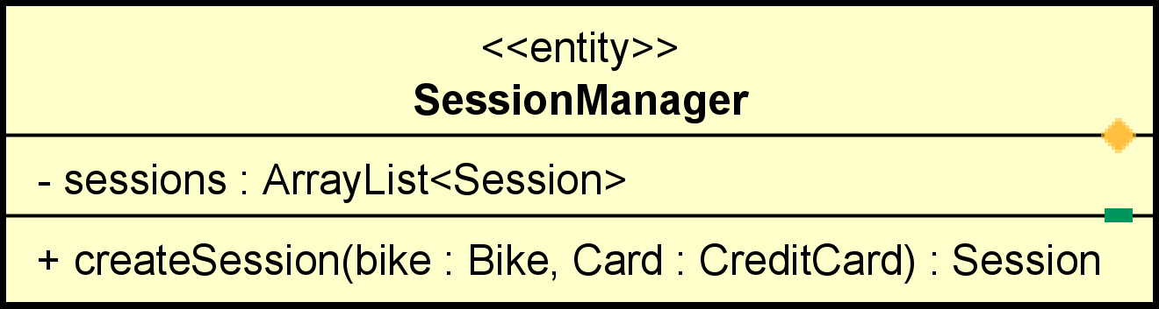

**Attribute**

|  |  |  |  |  |
| --- | --- | --- | --- | --- |
| # | Name | Data type | Default value | Description |
| 1 | sessions | ArrayList<Session> | Empty ArrayList | List of sessions |

**Operation**

|  |  |  |  |
| --- | --- | --- | --- |
| # | Name | Return type | Desciption |
| 1 | createSession | Session | Create new session and add to list |

Parameter:

bike – the rented bike

card – the used card

Exception:

None

**Method**

None

# Class Diagram

